# AVR In-System Programmer (ISP) header

### **Prepare the AVR In-System Programming (ISP) header**

(Do **NOT** connect USB cable to the PC yet)

Connecting the AVRISP header to the ATmega1284 is slightly awkward; miswiring is a common problem, and thus we'll do a few things now to prevent problems later. First, write the header's six pin hole names on tape applied to the header, as shown below. The AVRISP mkII wire 1 is denoted by the red wire on the ribbon cable and an arrow on the connector [1]

|  |  |  |
| --- | --- | --- |
|  |  |  |

Get six equal-length wires (use the long green wires in your kit) and use tape to label them with the same names on both ends, as shown. On one end, also write the ATmega1284 *pin* number (*not* port number) that matches the name (i.e., GND is 11, VCC is 10, RESET is 9, SCK is 8, MISO is 7, and MOSI is 6).

|  |  |
| --- | --- |
|  |  |

Connect the unnumbered side of each wire to the header, matching each wire name to the hole name:

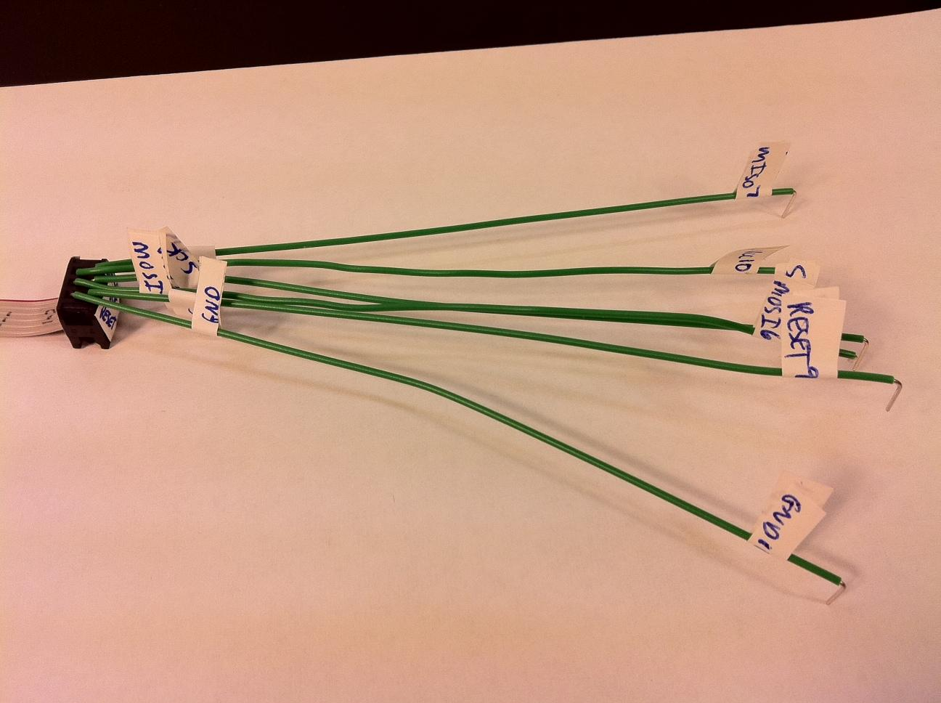

Tape down the wires onto the header to prevent disconnection. Sort the unconnected side of the wires by pin number (6, 7, 8, 9, 10, 11, with 6 on top), and apply tape to their center to help preserve that order, as shown below. Note that some wires will have to cross.[2]

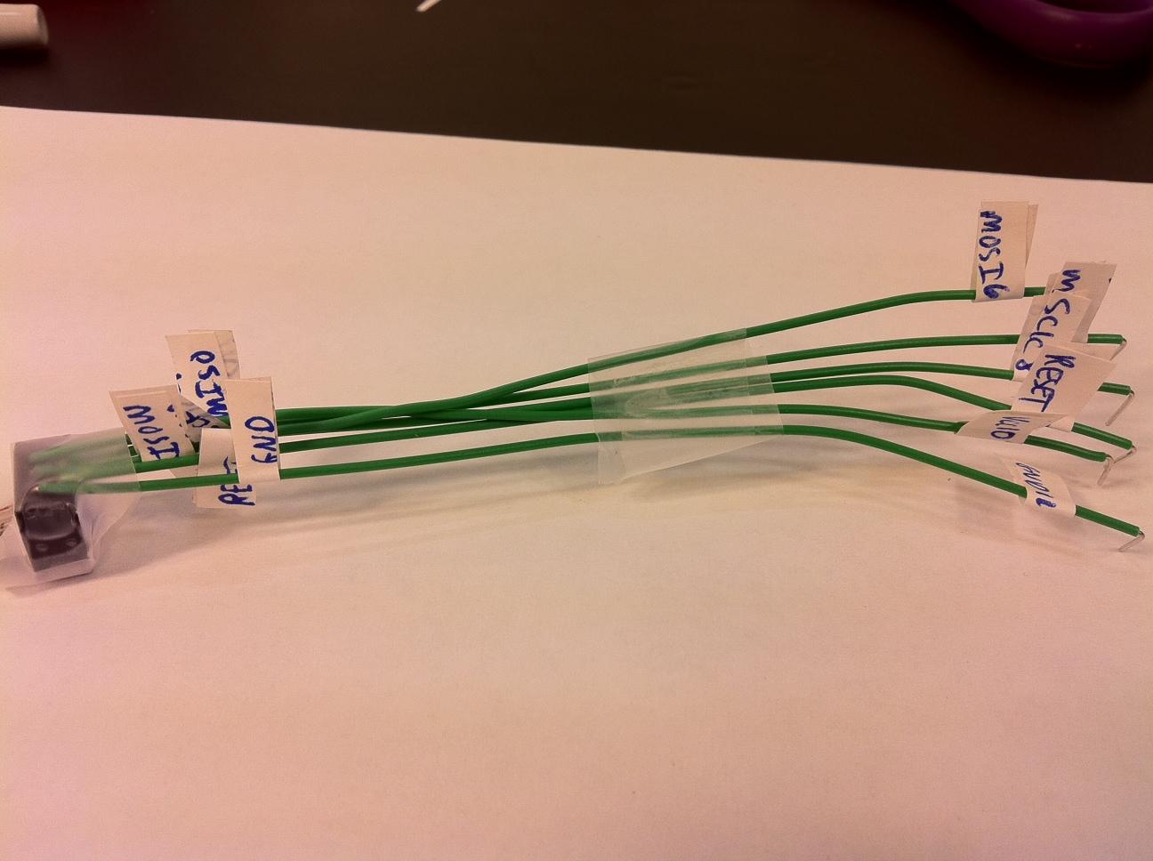

Completed AVRISP header.

### **Connect the AVRISP header to the microcontroller**

The header's six wires need to connect to the ATmega1284's pins 6-9 and VCC/ground. However, we may be connecting and disconnecting those wires frequently. To avoid such connecting/disconnecting close to the microcontroller, run 4 wires from the ATmega's pins 6-9 to the upper-left of the board, starting with row 6 (to correspond to ATmega's pin 6), and add connections to VCC and ground, as shown. We taped the four-wire group onto the board to keep them neat.

|  |  |
| --- | --- |
|  |  |

### 

The board is ready to have the header connected. Insert each header wire into the proper row -- be careful that the wire numbered 6 is in row 6, the wire numbered 7 is in row 7, etc.

*Miswiring is a common error, so take your time.*

|  |  |
| --- | --- |
|  |  |

### **Connect AVRISP to PC**

Plug in the USB cable (came with the AVRISP) from the blue AVRISP device to the PC. The PC recognizes a new USB device. **NOTE:** If this is your first time connecting the AVRISP device, your PC may indicate that you need to install the drivers for the device. Follow the on-screen instructions; if unsure, refer to our [AVR FAQ - Installing the AVRISP](https://docs.google.com/document/d/1GbuMfqc1_hnPtL9REofvAr_veMz-wAk5KNXVl_8QNtw/edit?usp=sharing).

The AVR's internal LED (indicating USB connectivity with the PC) should be green. Apply power to the board. The AVRISP's external LED (indicating connectivity with the ATmega1284) should illuminate green.

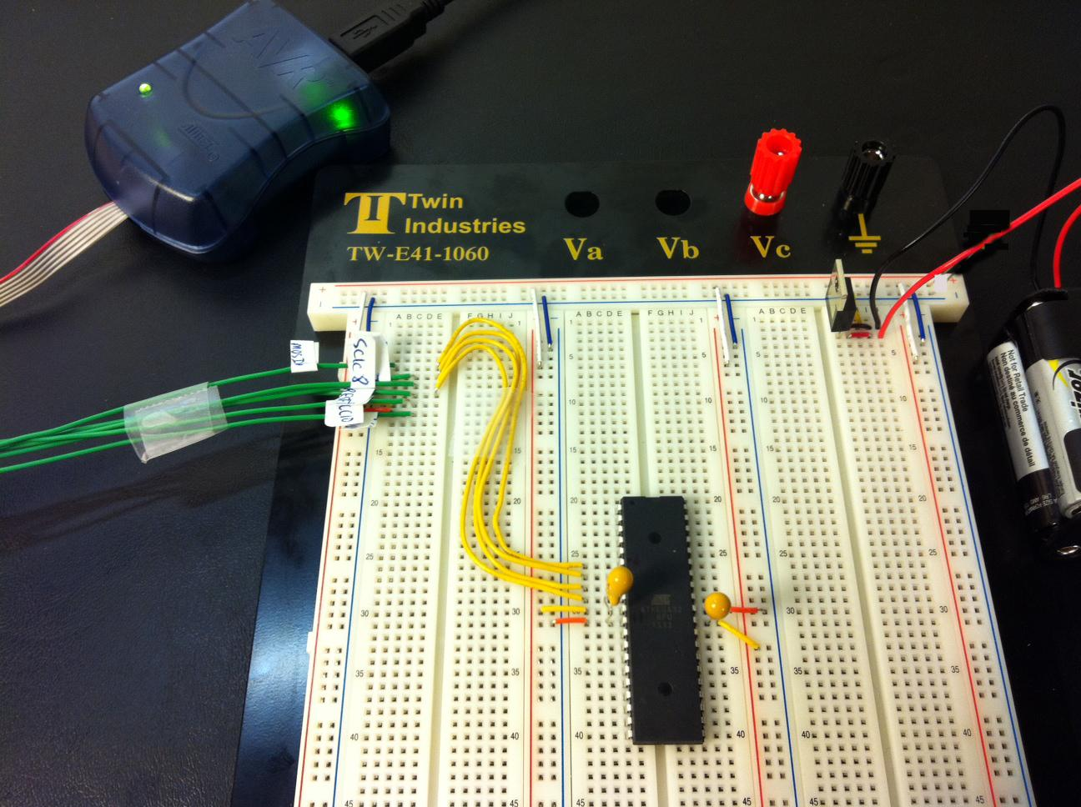

1. The AVRISP document's diagram, not shown, shows the header from the top side rather than the bottom side having the holes, which confuses many people.
2. Better connectors can be created later if the student is interested, requiring different connector parts and wires. Ask your TA or Professor.